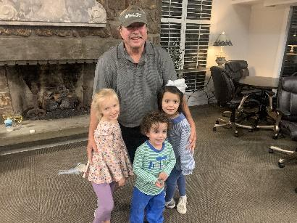

2024 AG AVIATION GOLF TOURNAMENT

WHEN: OCTOBER 19 & 20, 2024

WHERE: RED APPLE INN & COUNTRY CLUB, HEBER SPRINGS, AR

TEE TIME: SATURDAY, OCTOBER 19, SHOTGUN START 9:00 AM
(2 PERSON SCRAMBLE)
SUNDAY, OCTOBER 20, SHOTGUN START 9:00 AM

FEE: $175.00 PER PERSON (DINNER ONLY: $45.00)

THE COST INCLUDES: 2 ROUNDS OF GOLF – CARTS ARE FOR PLAYERS ONLY!
HAPPY HOUR 6:00 TO 7:00
DINNER AT THE RED APPLE INN SATURDAY 7:00 PM

PLEASE CALL THE RED APPLE INN 1-800-733-2775 TO RESERVE A ROOM.
RESERVATION CODE: AG AVIATION

ROOM RATES: INN ROOMS $150.00, 2 BR CONDO $235.00

This year the AA Golf Tournament donation will go to the:
William Austin Scrogin Agriculture Aviation Scholarship
(Delta State University)

Scott Rainey Memorial Scholarship

FOR MORE INFORMATION CALL: LATHAN BUSBY 870-734-7278
BRYANT OTTO 501-327-7714
MICHAEL HUTCHINS 870-672-2089
BRENDA WATTS 870-377-5241

